DealersAutoCenter Task
Task1: Dealer Vehicle Management:
1)Overview
This is a Spring Boot REST API to manage vehicle dealerships. It supports operations for managing dealers and their vehicles, including custom queries like fetching all vehicles from PREMIUM dealers only.
2)Entities (Auto generated using JPA):
Vehicle
Field | Type | Description
id | Long | Auto-generated primary key
model | String | Vehicle model name
price | Double | Vehicle price
status | Enum | AVAILABLE or SOLD
dealer | Dealer | Owning dealer (ManyToOne)

Dealer
Field | Type | Description
id | Long | Auto-generated primary key
name | String | Dealer name
email | String | Unique and valid email address
subsType | Enum | BASIC or PREMIUM subscription type
vehicles | List | One-to-many list of vehicles

3)API endpoints ( I have attached dealerVehicleAPI.json in email. It can be imported in postman. )
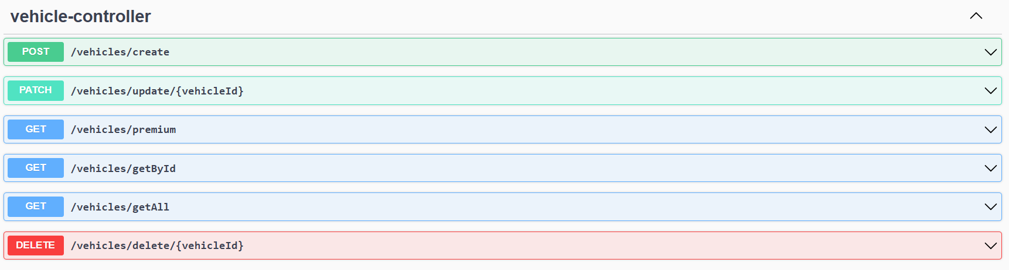
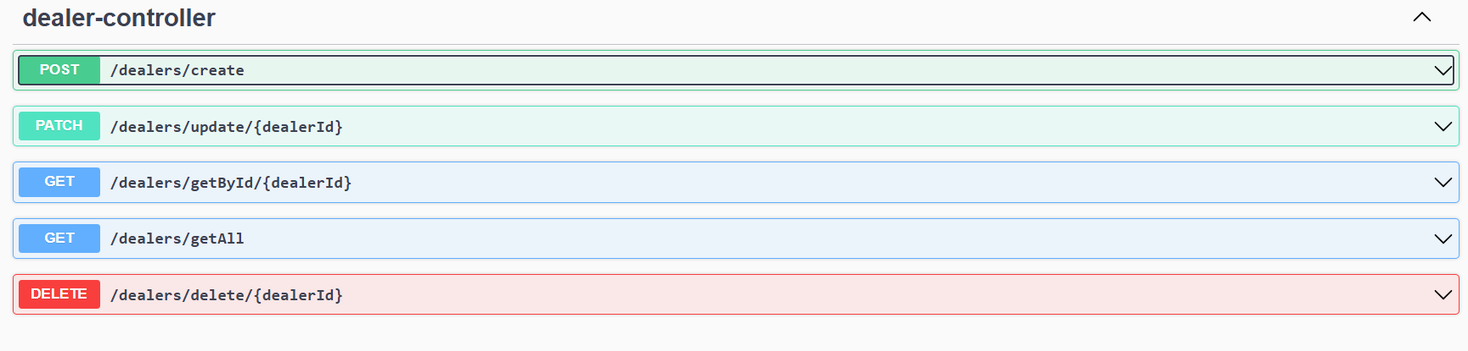
Dealer

1)
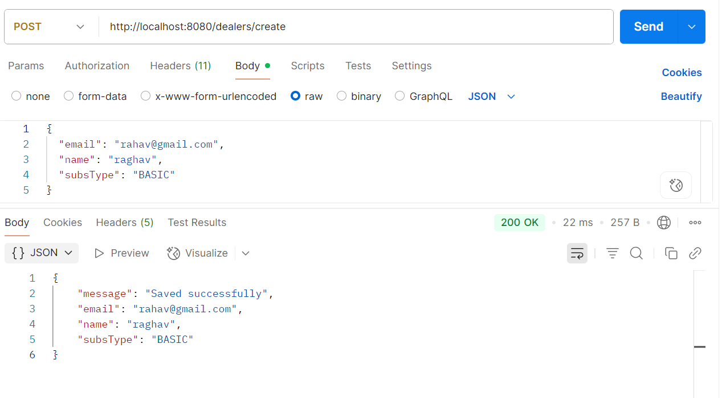
2) 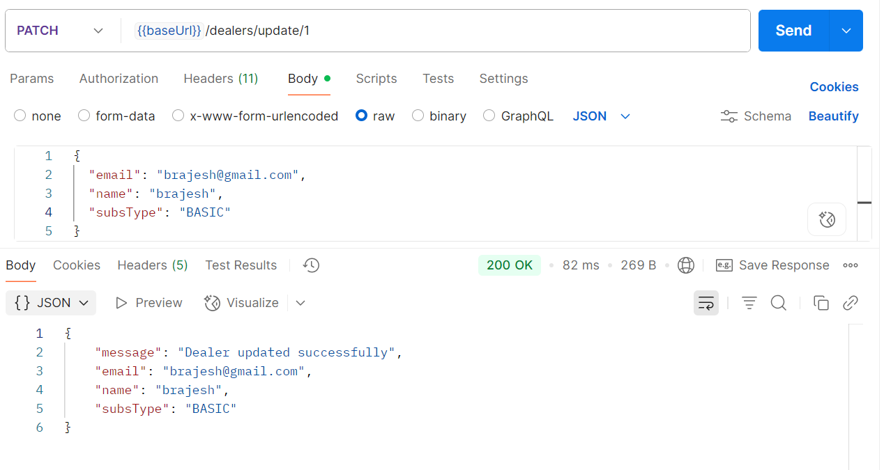
3) 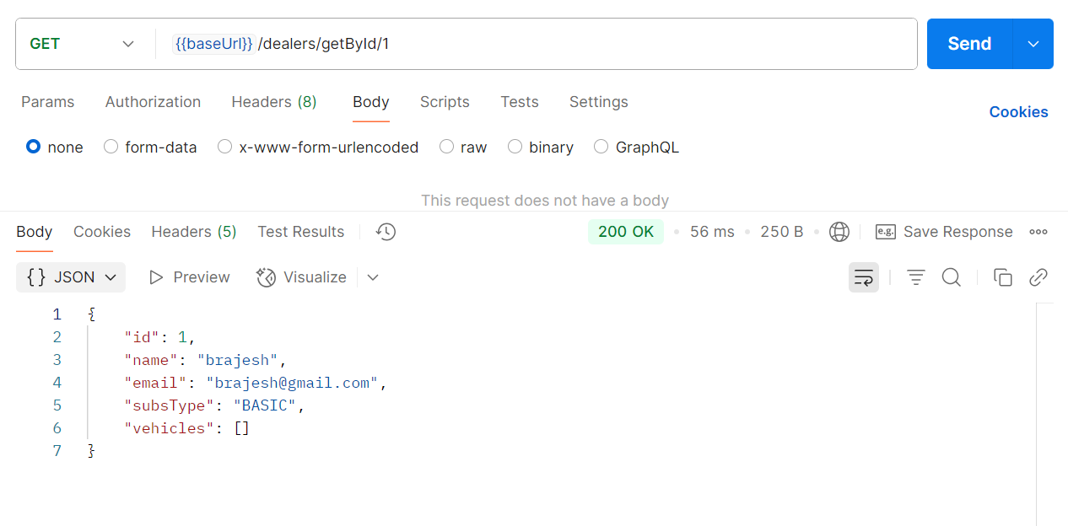
4) 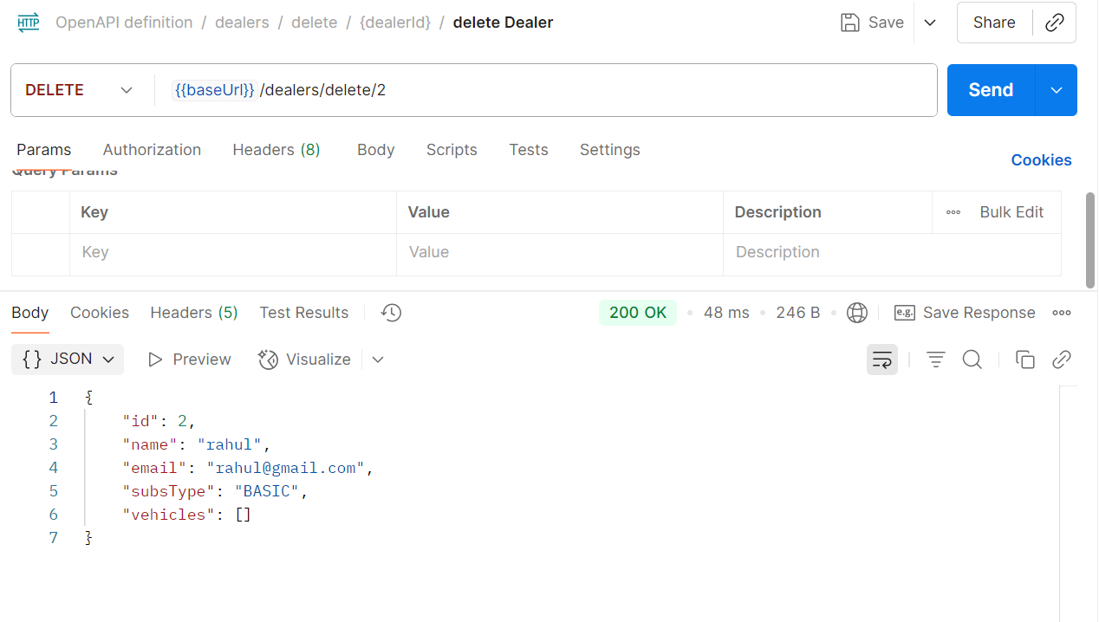
Vehicles
1)
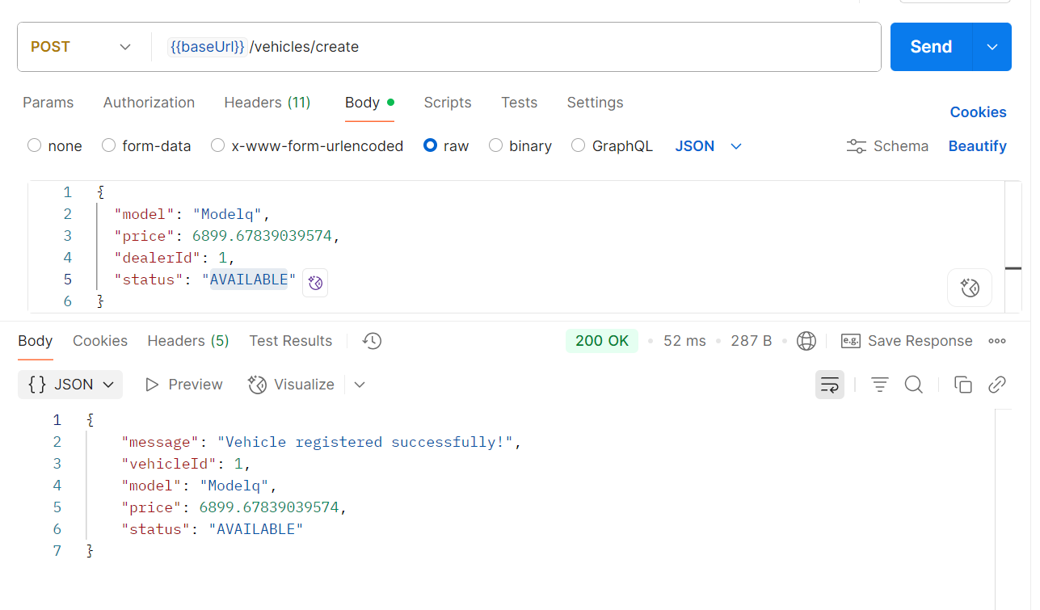

2) Get premium dealers vehicle
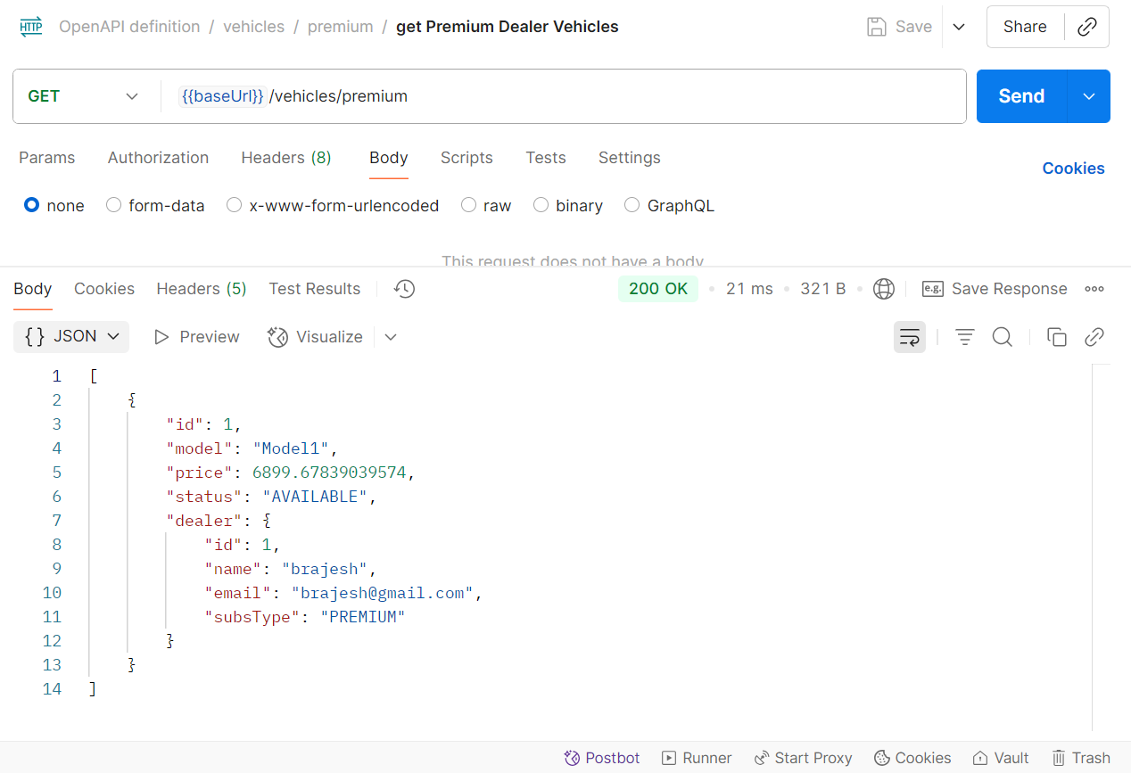
3) 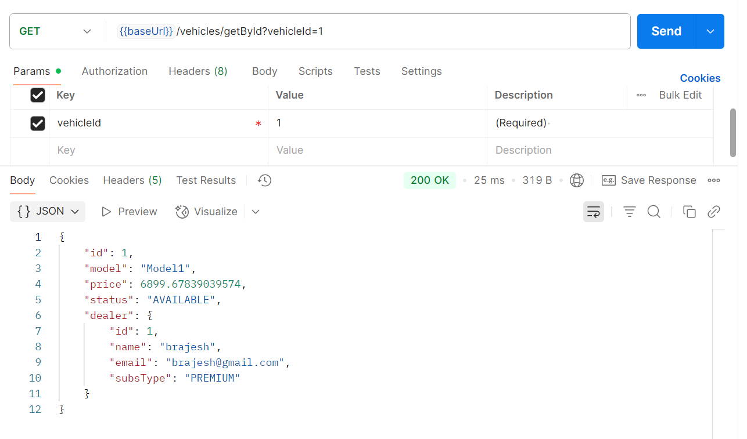
4) 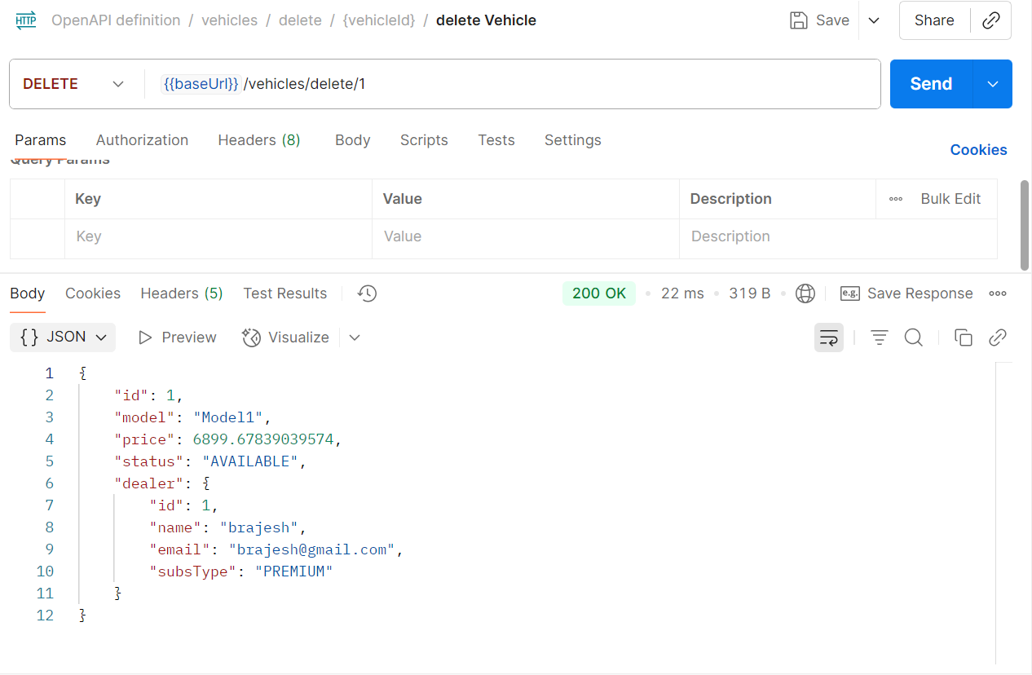
4)Deployment link : https://github.com/brajeshBrajesh/dealersautocenterTask/tree/task1_dealer_vehicle_management
5)How to run
1) Pre-requisites: Configure postgres in port : 5432 and made database with name = dealerdb
2)Clone repository from github repo provided in step 4 and run spring boot application. This will run application on port:8080
3)Import dealerVehicleAPI.json file in Postman. This will postman collection.
4)Hit API’s and test.
6) Attachments on email
- dealerVehicleAPI.json to be imported on postmen.
- dealer-vehicle-management-0.0.1-SNAPSHOT.jar file :Can be run directly

